Vocation Education and Training – Enrolment requirements
If you're studying nationally recognised training in Australia from 1 January 2015, you will be required to have a Unique Student Identifier (USI).
How to Obtain a Unique Student Identifier (USI)
The Unique Student Identifier is issued by the Australian Department of Industry and will remain with you for life, enabling you to access an online account where you may retrieve your training records. As you may be required to provide this number when you enrol with a training provider, you should keep it somewhere safe but accessible.
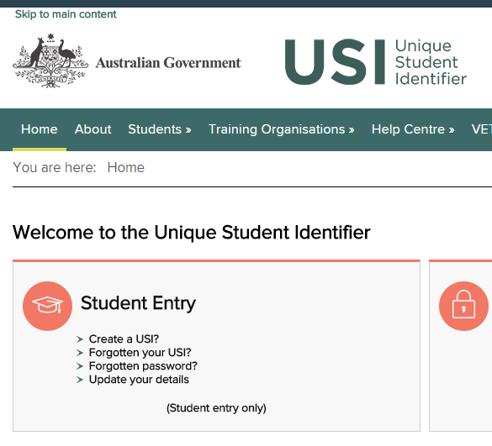
This is not the Student Identification Number issued by school or training provider at the time of enrolment. This is a separate number that schools and training organisations use to identify students and to provide access to the systems used throughout the Institute.
To obtain a Unique Student Identifier online, at no cost:
- Visit www.usi.gov.au and click through to “Create a USI”
- Have an individual email or mobile as each application must have a different email address.
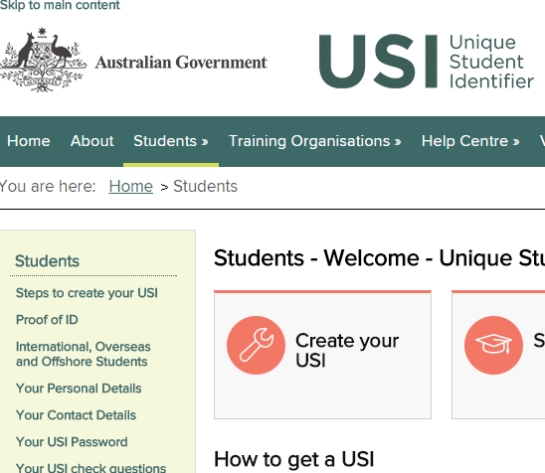
- Have at least one form of ID ready which may include: Medicare Card, Driver’s License, Birth Certificate, Australian Passport, Visa (with non-Australian Passport), Immigration Card or Citizenship Certificate.
Further information about the Unique Student Identifier can be obtained at www.usi.gov.au.
Please be aware that RTO (Registered Training Organisations) request enrolment data from the schools including USI, SCSA number, Student name and address and parent contact details. This could be a TAFE course external to school or a qualification delivered at Cecil Andrews. Students cannot be enrolled and/or resulted without a USI and failure to obtain a Certificate II or above could mean they do not obtain a WACE at the end of Year 12.
Once you have your USI please forward the email to steven.dimech@education.wa.edu.au so we can supply it to the training organisation your child’s certificate is issued by.
Alternatively please print clearly below and return to the Front Office asap.
Student Name: ___
USI:
10 digits – combination of letters and/or numbers.
Please be very clear to avoid confusion and data entry mistakes. Common errors: number 2 and letter Z, letters U and V, number 5 and letter S, number 9 and letter G
Note that legal names must be used. Please notify the school if any student details need to be changed.

